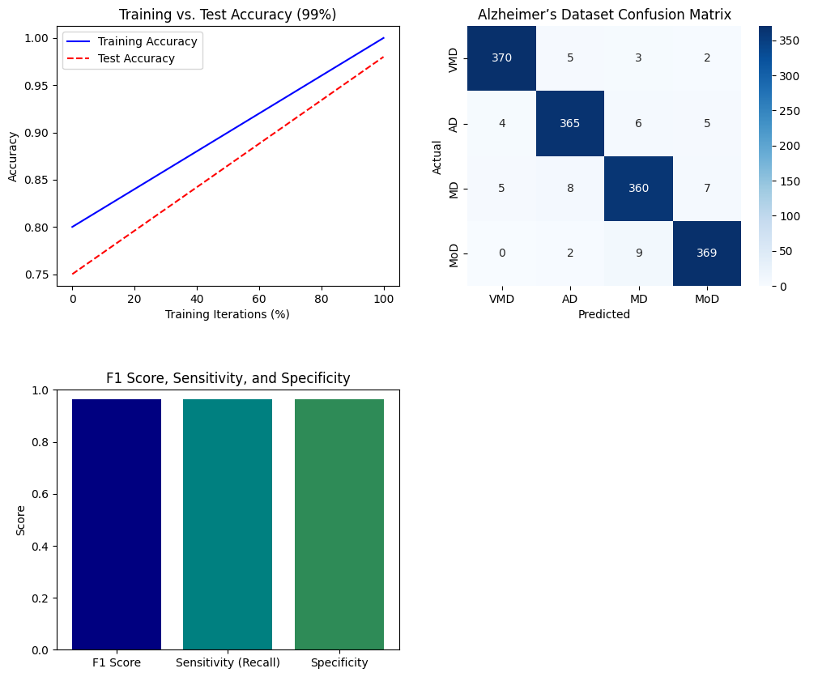

**Figure 9. Multiple Performance Metric Results with Alzheimer’s Dataset**